Simple Beam Rebar Detailing
Technical Specification
Revision 2 — 2026-09-08
Scope: single-span, rectangular concrete beam. This document covers pure detailing logic — bar geometry, placement, and quantities — with no flexural or shear design calculation performed. Bar sizes, counts, and base dimensions are user inputs; this spec defines how those inputs become placed rebar geometry.
Modeled after the workflow of CADS Rebar Extensions for Revit, built from first principles for a custom pyRevit / Revit API tool.
ABOUT REVISION 2
This revision incorporates 40 amendments (A1–A40) arising from the Wayfinder decision cycle, root issue #1 in the rft-beam-detailing repository. Each amendment is traced to its deciding ticket in docs/spec-amendments.md.
Amendments are marked inline throughout this document as [A…] with the deciding ticket number. Passages that changed materially carry a shaded note like this one.
Revision 1 closed §9 open item 1 (confirmed, not changed) and open item 3 (stirrup leg dimensions, now specified in §7). Open item 2 (multi-span) remains deferred.
Six residual questions (R1–R6) are listed in §11; they are deliberately unresolved and must be answered as acceptance criteria during implementation rather than assumed.

Contents

1. Notation
Symbol | Meaning
L | Beam span length — centreline-to-centreline distance between supports [A6, #3]
b, h | Beam cross-section width and depth
cover | Concrete cover to stirrup outer face. Context-dependent: the beam’s cover governs §4, §6 and §7; the supporting element’s own cover governs the §2 anchorage formulas [A4, #2]
ØTOP, ØBTM | Diameter of top / bottom main bars (one diameter per face)
Østirrup | Stirrup bar diameter
Øspacer | Spacer bar diameter, separating stacked bar layers. User input, default 16 [A1, #4]
Øcrack | Crack / skin bar diameter. User input, default 12 [A2, #5]
LD | Development (anchorage) length required for a bar
a, b (a_t, b_t for top) | Straight and bent legs of an anchorage detail. Both are measured to the theoretical corner — the point where the two bar centrelines would meet at a sharp corner (BS 8666-style datum), not the actual straight run before the bar curves [A5, #12]
Dagg | Maximum aggregate size
H_avail | Clear height available for crack / skin bars between main bar layers

1.1 Steel grades [A3, #13]
Material is a first-class property of every bar. Egyptian Code (ECP) designations apply:
Bar category | Grade | fy | Form
Stirrups | St 24/35 (mild) | 240 MPa | Plain round
Top main bars | St 36/52 (high tensile) | 360 MPa | Deformed
Bottom main bars | St 36/52 (high tensile) | 360 MPa | Deformed
Crack / skin bars | St 36/52 (high tensile) | 360 MPa | Deformed
Spacer bars | St 36/52 (high tensile) | 360 MPa | Deformed
Rule: all bars other than stirrups use high tensile steel; stirrups use mild steel. Two distinct Revit RebarBarTypes are therefore in play within a single beam, each carrying its own grade and its own bend radius.

2. Development Length & End Anchorage
Rule: where the support width is insufficient for a straight development length, the bar is split into a straight run ‘a’ plus a bent leg ‘b’, such that a + b = LD.

2.1 Top bar anchorage (into support)
a_t = Support width − Cover − ØBTM
ØBTM (not ØTOP) is used deliberately: this sizes the clearance so the bent top bar does not clash with the bottom bar’s own bend at the joint.
b_t = LD_top − a_t
LD_top is computed from a user-specified multiplier. Top and bottom bars take independent multipliers — defaults 60 × ØTOP and 55 × ØBTM — each shared across both beam ends. Multipliers are code- and grade-dependent user inputs, never hardcoded; the UI states the grade they assume (St 36/52). [A10, #2 #13]

2.2 Bottom bar anchorage
a_btm = Support width − Cover
b_btm = LD_btm − a_btm
A7 [#2] — OPEN ITEM 1 CLOSED: FORMULA CONFIRMED, NOT CHANGED
Revision 1 flagged a_btm as an unconfirmed placeholder that mirrored the top-bar logic. It is now confirmed correct as written.
Rationale: the top and bottom bent legs overlap in depth and therefore require horizontal separation. For ØTOP 12 / ØBTM 16 the required centreline separation is (ØTOP + ØBTM)/2 = 14 mm. Only this formula delivers it — a_btm − a_t = ØBTM = 16 mm, clearing by 2 mm. Subtracting ½ØBTM instead gives 8 mm, and subtracting ØTOP gives 4 mm; both clash.
This also explains why §2.1 subtracts ØBTM: a_t = a_btm − ØBTM backs the top bar off by exactly one bottom-bar diameter, which is the clash avoidance §2.1 describes.
Note that Figure 1 is schematic and not to scale — it draws a_btm shorter than a_t, and neither drawn dimension matches its own caption. The drawing cannot be used to verify these formulas.

2.3 Governing constraints (apply to both top and bottom)
- Minimum bend length: if the computed b is < 200 mm, clamp it to b = 200 mm.
- Straight-leg cap: where the available width alone already exceeds LD, cap the straight run so anchorage is not grossly over-delivered. [A11, #2]
a = min(a_formula, LD − 200)
b = max(200, LD − a)

# total anchorage = LD exactly, 200 mm minimum bend preserved
Without this cap, a 600 mm support with LD = 300 mm would deliver 559 + 200 = 759 mm of anchorage against a 300 mm requirement — 2.5× the steel required.
- Mandatory hook rule (supported ends only): at a supported end, a hook is always formed — even if LD is less than the support width, so the bar could anchor straight — with a minimum leg of 200 mm.
A12 [#11] — CHANGED: MANDATORY-HOOK RULE NOW SCOPED TO SUPPORTED ENDS
Revision 1 stated flatly that "a hook is never omitted." That is now scoped: the rule applies only to ends where a support is detected.
A beam end with no detectable support receives a straight bar with no hook, anchorage length LD. See §2.5.
A13 [#8] — TERMINOLOGY: "HOOK" HERE MEANS THE BENT LEG
"Hook" throughout §2 means the bent leg b — an L-bend built as a second curve segment of the bar. It does NOT mean a Revit RebarHookType, which is a fixed catalog element whose length is bar diameter × a multiplier and cannot be driven by an independent length such as b = LD − a.
Implementers must build the L-shape as a 2-segment curve list with startHook and endHook set to null. Reaching for a RebarHookType here produces a silently wrong leg length.

2.4 Support width and cover [A8, A9, #2 #11]
- Support width is read from the model at each beam end and is user-overridable.
- Support detection covers any structural support — column, wall or girder — using the detected element’s width or thickness. A beam framing into a girder is still a single span; this does not bring multi-span into scope.
- Cover in the a_t / a_btm formulas is the supporting element’s own cover, not the beam’s, because the dimension is measured inside the support.

2.5 Ends with no detectable support [A12, A14, #11]
- A straight bar with no hook, anchorage length LD, is placed. The mandatory-hook rule of §2.3 does not apply.
- Cantilever and free ends are out of scope for v1. They fall into this path and the tool must warn rather than silently produce the geometry.
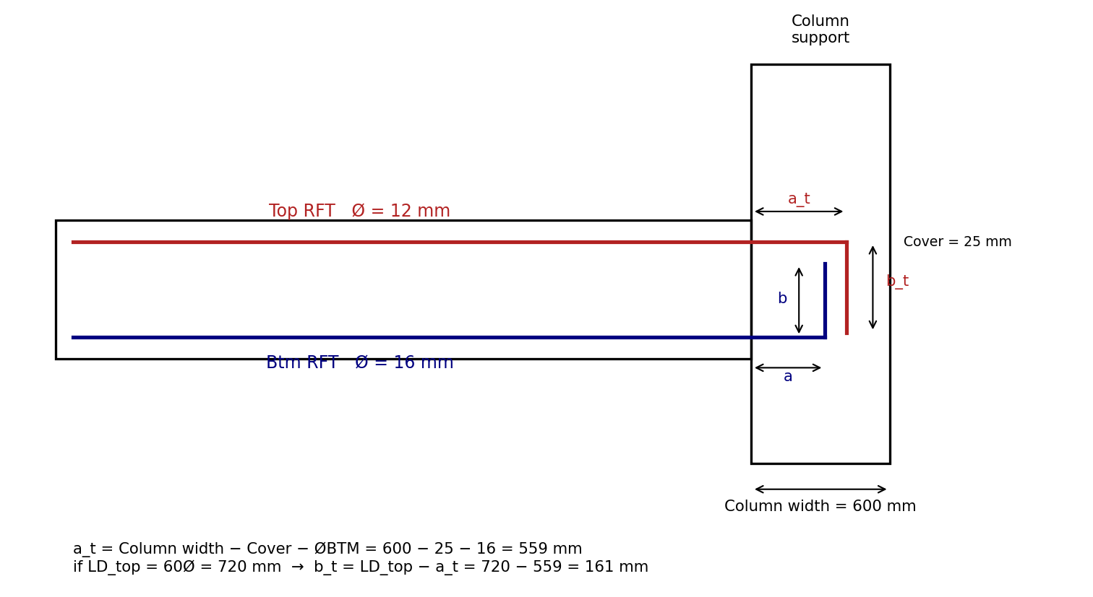
Figure 1 — Development length / end anchorage detail. Schematic only; not to scale (see A7).

3. Stirrup Distribution
Rule: beam span is split into three zones of equal length L/3 — dense stirrup spacing near both supports, normal spacing at midspan. This is a simplified 3-zone convention, not derived from a shear-demand diagram.
zone 1 (support A): 0 → L/3 — dense spacing
zone 2 (midspan): L/3 → 2L/3 — normal spacing
zone 3 (support B): 2L/3 → L — dense spacing

3.1 Zone clipping [A15, A16, #3]
L is measured centreline-to-centreline of the supports, but stirrups exist only between the support faces. The zone boundaries and the placement region are therefore in different datums, and the arrays are clipped:
region_start = face_A + 50
region_end = face_B − 50

zone 1 array: [ face_A + 50 , L/3 ]
zone 2 array: [ L/3 , 2L/3 ]
zone 3 array: [ 2L/3 , face_B − 50 ]
The first and last stirrup both sit 50 mm from a support face — the distribution is mirrored.
A16 [#3] — CONSEQUENCE: THE DENSE ZONES ARE SHORTER THAN L/3
Because zones are defined on the centreline span but clipped to the clear region, zone 1 and zone 3 each carry stirrups over less than L/3 — short by roughly half the support width plus 50 mm — while zone 2 receives the full L/3.
This is a direct consequence of defining zones on the c/c span and is recorded here so it is not later mistaken for a defect.
Degenerate-case guard [A17]: if face_A + 50 ≥ L/3 — a short span and/or a wide support — zone 1 has no valid array length. The tool must error with a clear message rather than pass a non-positive length to the API. The same test applies at the far end for zone 3.

3.2 Spacing semantics [A18, #3 #8]
Dense and normal values are maximum spacings, exactly as “Ø10 @ 150” conventionally means. Spacing is redistributed evenly to fill each zone exactly, so there is no remainder to allocate and no rounding rule to choose.
Dense and normal spacing values are user inputs; the worked example is Ø10 @ 150 dense, Ø10 @ 200 normal.
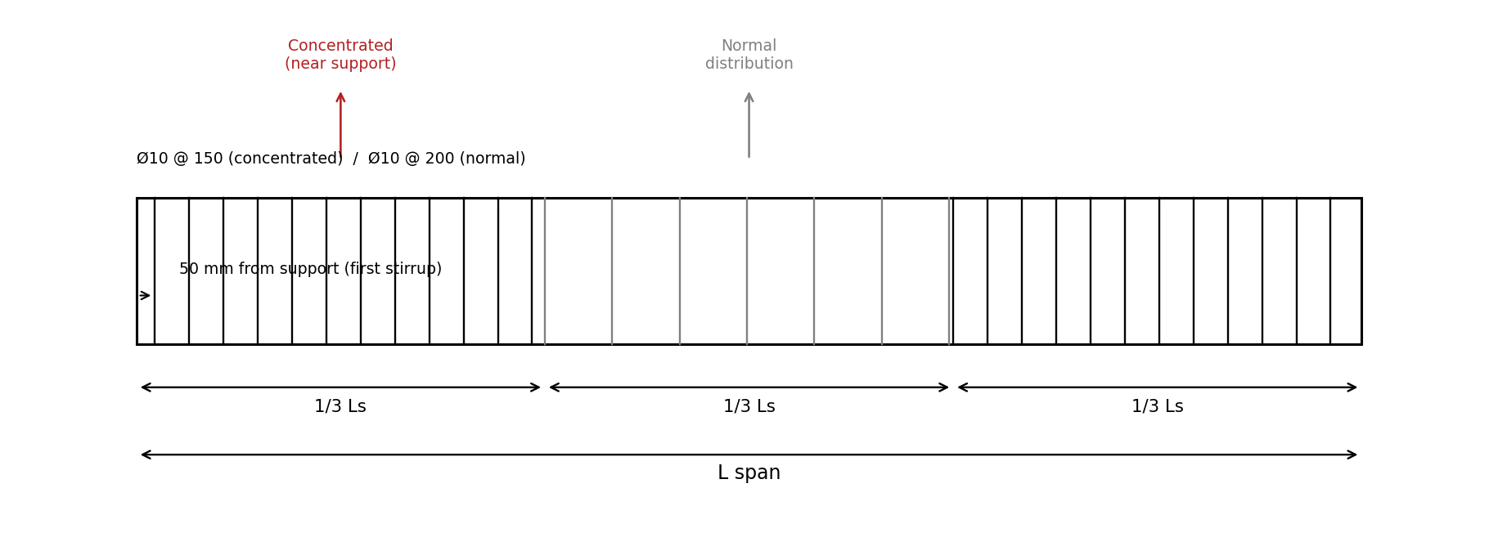
Figure 2 — Stirrup distribution across L/3 zones

4. Main Bar Layer Offset (Cross-Section)
Rule: the centreline of the first (outermost) bar in a layer is offset from the beam face by:
offset₁ = Cover + Østirrup + (½ × Øbar)
This is measured from the beam face to the centre of the first bottom (or top) bar — not to the stirrup, and not to the bar’s outer edge. It applies independently to the top layer (using ØTOP) and the bottom layer (using ØBTM).

4.1 Multi-layer accumulation [A19, A20, #4]
All rows within a face share that face’s single diameter. Each additional row adds one bar diameter plus one spacer diameter:
offsetₙ = offset₁ + (n − 1) × (Øbar + Øspacer) for n = 1..5
A19 [#4] — CHANGED: THE LAYER GAP IS THE USER-DEFINED SPACER DIAMETER
Revision 1 disagreed with itself: §4 called the layer gap "a user input" while §6.3 fixed a "convention: Ø16" spacer bar. These are now reconciled.
The vertical clear gap between stacked layers is Øspacer — a user input defaulting to 16. A physical spacer bar occupies that gap, so it is unambiguously a clear distance rather than a centre-to-centre pitch.
A21 [#4, #6] — MINIMUM CLEAR SPACING IS HORIZONTAL-ONLY
§6.2’s min_spacing governs the horizontal direction only. It does not constrain the vertical gap between layers, which is set outright by Øspacer.
Accepted consequence: nothing prevents a vertical gap below the horizontal minimum. A Ø16 spacer under Ø20 bars yields a 16 mm vertical gap where 25 mm would be required horizontally. This was chosen deliberately for user control. Whether to warn is residual question R1 (§11).
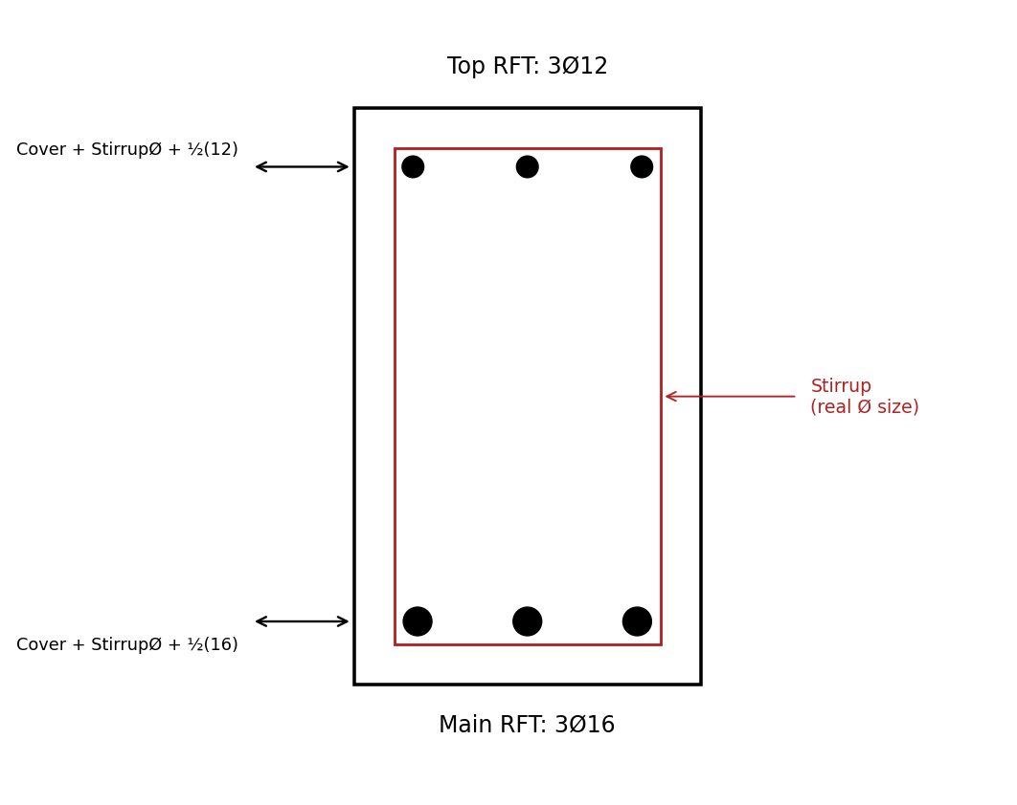
Figure 3 — Main bar layer offset, distinct top (3Ø12) and bottom (3Ø16) bar sizes

5. Crack / Skin Reinforcement (Beam Depth > 700 mm)
Trigger: only applies when h > 700 mm. If h ≤ 700 mm then n_crack_layers = 0 and this section does not fire.

5.1 Available height
H_avail = h − offset_top − offset_btm
offset_top and offset_btm are computed per §4, to the centreline of the top and bottom main bars respectively.
A26 [#4] — MULTI-LAYER DATUM: INNERMOST LAYER
For a multi-layer beam these offsets are measured to the centreline of the innermost top and bottom layers, so H_avail is the true unreinforced web height. The web face between the innermost layers is the region actually lacking reinforcement, which is what skin bars address.
Revision 1 never addressed the multi-layer case, so this fills a gap rather than contradicting the earlier text.

5.2 Layer count and spacing
Given a user-specified maximum spacing s_max between crack-bar layers:
n_gaps = ceil(H_avail / s_max)
n_crack_layers = n_gaps − 1
actual_spacing = H_avail / n_gaps

# actual_spacing ≤ s_max, evenly distributed — no single odd leftover gap
Crack bars are placed at each internal division point along H_avail, one bar per side (left / right face) per layer.

5.3 Diameter, position and extent [A22, A23, A24, A25, #5]
- Diameter: Øcrack is a user input, default 12. Revision 1 listed only s_max, leaving crack bars with no placeable diameter.
- Horizontal position: uses the §4 rule — Cover + Østirrup + (½ × Øcrack) from each side face to the bar centreline. This matches Figure 4, which draws the crack bars on the stirrup’s inner face.
- Longitudinal extent: crack bars run the full span and embed straight into the support with no hook. They are crack-control steel, not flexural tension, so §2’s anchorage machinery does not apply. Embedment depth is residual question R2 (§11).
- Spacing validation: crack bars are exempt. One bar per side per layer leaves no horizontal spacing question, and their vertical positions are even by construction via actual_spacing.
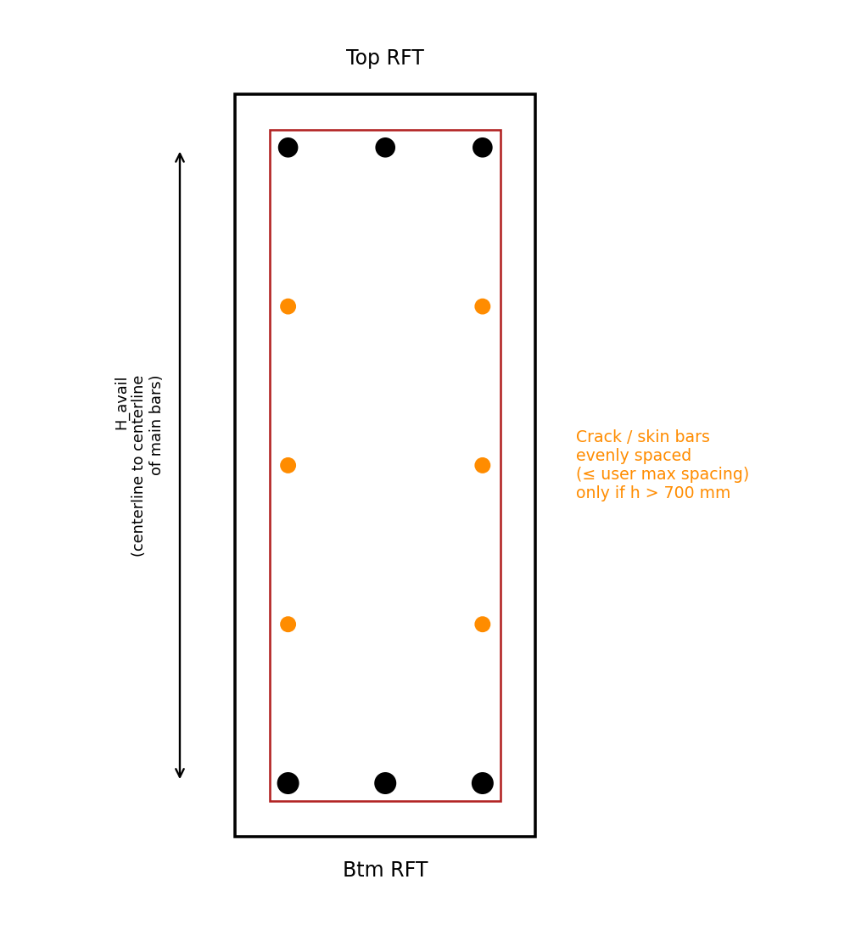
Figure 4 — Crack/skin bar layers between main bar rows

6. Bar Spacing Rules (Cross-Section Arrangement)

6.1 Corner-bar rule
A bar is always placed at each corner of the stirrup cage; remaining bars in that face are then distributed with equal spacing between the corner bars.

6.2 Minimum clear spacing between bars
min_spacing = max( 25 mm, Øbar, 1.33 × Dagg ) — if Dagg is user-defined
min_spacing = 50 mm — fallback, only if Dagg
is NOT defined
Dagg (max aggregate size), when provided, always governs over the 50 mm fallback. This rule constrains the horizontal direction only (A21).
Optional override [A29, #6]: a user-supplied override acts as a floor, never a reduction:
governing_min_spacing = max( formula_result, user_override )
The override can only increase the governing spacing, so it cannot be used to detail below the computed minimum.

6.3 Multi-layer bars (more than one row, same face)
- Up to 5 layers maximum per face.
- Option 1: single wide row (all bars in one line, no stacking).
- Option 2: stacked rows separated by a spacer bar of diameter Øspacer (default 16).
spacer_length = b − 2×Cover − 2×Østirrup
The user must be informed of resulting spacing per layer and the number of layers used, for both top and bottom faces independently.

6.4 Behaviour when spacing cannot be satisfied [A27, A28, #6]
The achieved clear spacing for n bars in one face is:
clear = (b − 2×offset − n×Øbar) / (n − 1) # offset per §4

invalid when clear < governing_min_spacing
On violation, behaviour follows the user’s §6.3 choice:
§6.3 option | Behaviour on violation
Option 1 — single wide row | Hard stop. Report the governing min_spacing and the achieved clear spacing; place nothing.
Option 2 — stacked rows | Auto-stack into additional layers until spacing is satisfied, capped at 5 layers, then report the resulting layer count and per-layer spacing.
If 5 layers cannot satisfy the governing minimum, that is a hard error in both options. The cap is absolute.
Note: stacking layers does reduce effective depth d for rows beyond the first. That is not accounted for here, since this tool performs no capacity or crack-width analysis — detailing only.

7. Stirrup Type (Closure / Hook Style)
Aligned to CADS Rebar Extensions convention — stirrup “type” governs the closure and hook style of a single 2-leg perimeter stirrup, not leg count. Multi-leg crossties are out of scope for this tool, as in CADS’s base beam tool.

7.1 Leg dimensions [A30, #10]
Since §1 defines cover as measured to the stirrup outer face:
OUTER rectangle = (b − 2·Cover) × (h − 2·Cover)
CENTRELINE rectangle = (b − 2·Cover − Østirrup) × (h − 2·Cover − Østirrup)
The centreline rectangle is what the Revit API receives. The centreline sits ½Østirrup inside the outer face on each of two opposing sides, hence one full Østirrup subtracted per dimension.
A30 [#10] — OPEN ITEM 3 CLOSED: DERIVED, NOT INVENTED
Revision 1 referenced stirrup leg dimensions conceptually but never reduced them to formulas. The formula above is a derivation from §1’s own cover definition, independently corroborated by two unrelated existing formulas:
Check 1 — §6.3’s spacer length. The spacer spans between the inner faces of the two vertical legs, each at Cover + Østirrup from its beam face, giving b − 2·Cover − 2·Østirrup. That is exactly §6.3’s spacer_length.
Check 2 — §4’s main bar offset. A bar bearing on the stirrup’s inner face has its centreline at (Cover + Østirrup) + ½Øbar. That is exactly §4’s offset formula.
Two independent formulas fall out of the same cover interpretation, so this is the reading the spec was already using implicitly.

7.2 Closure types
Type | Description | v1
1 | Closed perimeter, hook overlap at top-right corner | Ships
2 | Closed perimeter, hook overlap at top-left corner | Ships
3 | Nested double perimeter (inner closed loop) — for larger sections needing extra confinement | PARKED
4 | Open U-shape, no top closure (hooks at both top ends instead) | Ships
A31 [#7] — CHANGED: TYPE 3 IS PARKED; THE INPUT NARROWS TO (1, 2, 4)
Type 3 requires two separate Rebar elements (outer loop plus inner loop), since the API has no single multi-loop rebar element. That part is workable.
What blocks it: the inner loop’s dimensions, diameter and corner rule are entirely undefined in this spec. §7.1 dimensions only the outer perimeter. Inventing an inner-loop rule is prohibited, so type 3 waits for a spec amendment. This is residual question R6 (§11).
Types 1 vs 2 [A32, #7]: type 2 is type 1 with the same 4-curve loop and the same winding direction, cyclically rotated so that a different corner becomes the first curve. This is one parameterized code path taking a starting-corner index — not two separate constructions, and not a reversed loop, which would flip which face the hook swings toward.

7.3 Hook geometry [A33, A34, #13]
- Angle: fixed at 180° semicircular. This is the ECP / BS detail for plain round mild steel, which requires a full hook because it lacks the bond of deformed bar. Not a per-run user input.
- Length: derived from bar diameter via the hook type’s multiplier mechanism. Not exposed as a user input.
- Bar type: stirrups are placed with the mild St 24/35 bar type; every other bar uses high tensile St 36/52 (§1.1).
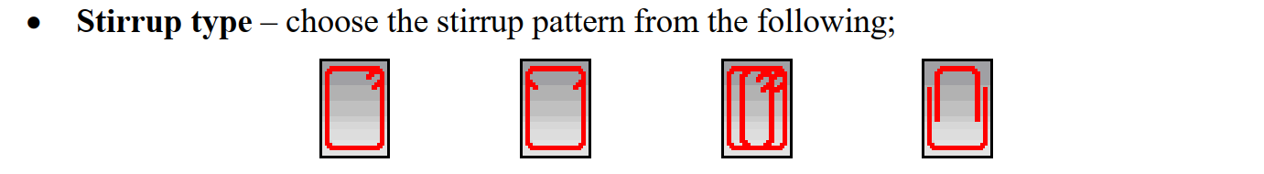
Figure 5 — Stirrup closure/hook type variants (CADS-aligned)

8. Summary — User Inputs vs. Calculated Outputs
Category | User Input | Calculated
Geometry | L, b, h, cover — pre-filled from the picked beam, editable. Dagg (optional) | —
Support | Support width per end — pre-filled from the detected support, editable | a / b legs, hook geometry
Materials | Two RebarBarType selections: mild (St 24/35) and high tensile (St 36/52) | —
Main bars | ØTOP, ØBTM, bar count per face, layer option (1 or 2) | bar length, layer offsets, spacer length
Layers | Øspacer (default 16) | layers used, spacing per layer
Stirrups | Østirrup, dense spacing, normal spacing, stirrup type (1, 2 or 4) | zone boundaries, stirrup count, leg dimensions
Development length | LD_top multiplier (60Ø), LD_btm multiplier (55Ø) | a, b legs (clamped ≥ 200 mm, capped at LD)
Crack bars | Øcrack (default 12), s_max — active only when h > 700 | n_crack_layers, actual_spacing
Spacing | min_spacing override (optional, acts as a floor) | governing min_spacing from formula or fallback

8.1 Shipped defaults [A36, #9]
Input | Default | Input | Default
cover | 25 mm | Øspacer | 16
Østirrup | 10 | Øcrack | 12
dense spacing | 150 mm | s_max | 200 mm
normal spacing | 200 mm | stirrup type | 1
LD_top | 60 × Ø | layer option | 1 (single wide row)
LD_btm | 55 × Ø | Dagg | blank
These reproduce this document’s worked examples out of the box. Dagg ships blank deliberately, so §6.2’s 50 mm fallback governs until an aggregate size is supplied.

8.2 Interface and reporting [A35, A37, #9]
- A single WPF / XAML form collects all inputs with cross-field validation.
- The dialog opens first; the user then picks the beam. Geometry and support fields stay disabled until a beam is picked, and re-picking re-populates them and re-runs support detection.
- Entered parameters persist per project, so detailing many beams in one project reuses the parameter set while a different project starts from defaults.
- Full output goes to the pyRevit output window: per-layer spacing and layer count for both faces (as §6.3 requires), zone stirrup counts and achieved spacings, computed a / b anchorage legs, and crack bar layer count and actual_spacing.
- A summary dialog carries the headline numbers plus any warnings. No file export in v1.

9. Open Items
Item | Status
1 — Bottom bar anchorage bend geometry (a_btm) | CLOSED. Confirmed correct as written; rationale in §2.2 (A7).
2 — Multi-span beam behaviour | STILL DEFERRED. Single-span remains the hard scope boundary. The tool should warn on, or refuse, a beam that is part of a continuous run rather than silently detailing it as simply supported.
3 — Stirrup leg dimensioning formulas | CLOSED for the outer perimeter, specified in §7.1 (A30). The inner loop of type 3 remains undefined, which is why type 3 is parked (A31, R6).

10. Implementation Constraints (Revit API)
Recorded here so the API decisions live alongside the geometry rules they serve. Full detail with sources in docs/research/revit-api-strategy.md and docs/research/stirrup-types.md.
- All detailing math in millimetres, matching this document 1:1. Convert only at the API call boundary via UnitUtils.ConvertToInternalUnits(v, UnitTypeId.Millimeters). No value is stored in feet.
- Longitudinal bars: Rebar.CreateFromCurves with RebarStyle.Standard. The §2 bend is a second curve segment, with startHook and endHook set to null (A13).
- Stirrups: RebarStyle.StirrupTie, a closed 4-curve loop (open for type 4), the mild bar type, and 180° hooks.
- Stirrup distribution: one rebar set per zone via SetLayoutAsMaximumSpacing on RebarShapeDrivenAccessor. Never SetLayoutAsNumberWithSpacing, which takes no array length and cannot be pinned to a zone boundary.
- Host validation order: RebarHostData.GetRebarHostData(beam) non-null, then IsValidHost(), then explicitly read back per-face RebarCoverType — an undefined face cover silently falls back to a document default and could masquerade as this spec’s Cover input.
- One Transaction per beam wrapping all bars and stirrup sets, with RollBack() on any exception, so a half-placed cage never commits.
NOT VERIFIED AGAINST A LIVE REVIT HOST
No live Revit host was available when these decisions were made, so every API finding above rests on documentation. Requiring empirical confirmation: default bend radii and the fillet/trim magnitude; real-world IsValidHost() behaviour; undefined-cover fallback behaviour; zone-set boundary interaction (R4); whether SetLayoutAsMaximumSpacing behaves identically for open and closed shapes; live-template stirrup shape names; and whether RebarStyle.StirrupTie permits 180° hooks.
The last item is load-bearing: if StirrupTie disallows 180° hooks, the mild-steel hook decision in §7.3 (A33) must be revisited.

11. Residual Questions
These are deliberately unresolved. Each must be answered as an explicit acceptance criterion during implementation rather than assumed, since this document is the source of truth and does not yet settle them.
# | Question
R1 | Should the tool emit a non-blocking warning when Øspacer < max(25, Øbar, 1.33 × Dagg)? §4.1 (A21) leaves the vertical direction unchecked.
R2 | Crack bar embedment depth. §5.3 fixes “straight, no hook” but not a length. A candidate consistent with §2 is Support width − Cover.
R3 | Unsupported-end anchorage length. §2.5 specifies a straight bar of LD, but with no support there is no region for that length to occupy. Either run to beam end − cover and warn that LD is not achieved, or require a manually supplied support width.
R4 | Zone-boundary duplicate stirrup. Can zone 1’s last bar and zone 2’s first bar coincide at L/3? Depends on the include-first / include-last flags. A prime candidate for the mock-object verification write-up.
R5 | Non-perpendicular wall support: is “width” the wall thickness or the swept intersection length?
R6 | Type 3 inner loop — dimensions, diameter and corner rule. This is the gap that parks type 3 (A31).

